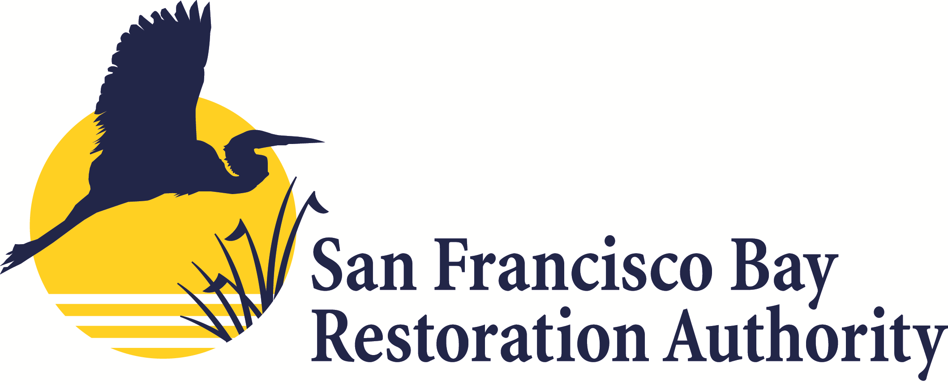

Grant Round 1: Frequently Asked Questions

- What is an eligible project location?
  - To be eligible, projects must be located within the nine Bay Area counties along the shorelines of San Francisco Bay, San Pablo Bay, Carquinez Strait, Suisun Bay, and most of the Northern Contra Costa County Shoreline to the edge of, but not including, the Delta Primary Zone, that are in areas consistent with guidance provided in the Baylands Ecosystem Habitat Goals Science Update (2015) and Subtidal Habitat Goals Report (2010), including:
    - In subtidal areas (lying below mean low tide), within a reasonable distance of the shoreline; or
    - In baylands, i.e., areas that lie between the maximum and minimum elevations of the tides over multiyear cycles, including those areas that would be covered by the tides in the absence of levees or other unnatural structures, including the portion of creeks or rivers located below the head of tide; or
    - On uplands adjacent to potential or other unnatural structures, including the portion of creeks or rivers located below the head of tide; or
    - On uplands adjacent to potential or actual tidal wetlands that can provide transitional habitat and/or marsh migration space, as well as areas that are needed to enhance the project’s resilience to projected sea level rise.
  - For more information, and the definition of “Along the Bay Shorelines” and “Creek Outlets,” please see Appendix B of the Restoration Authority’s Grant Program Guidelines.
  - Reference Appendix B of Grant Guidelines
- Is the geographic distribution of funds over the life of the Measure (20 years) or will the geographic distribution of funds be required for each grant round?
  - The geographic distribution of funds, included below, is over the life of the Measure (20 years). Thus, the minimum percentages, included below, shall be allocated to each of the four Bay Area regions over the 20 years of the Measure, and not necessarily for each grant year:
    - North Bay (Sonoma, Marin, Napa, and Solano Counties): 9% minimum allocation;
    - East Bay (Alameda and Contra Costa Counties): 18% minimum allocation;
    - West Bay (City and County of San Francisco and San Mateo County): 11% minimum allocation; and
    - South Bay (Santa Clara County): 12% minimum allocation.
  - The remaining 50% of total net revenue shall be allocated consistent with all other provisions of Measure AA.
- Will a project proposal receive more points the more programs and/or activities it meets?
  - Not necessarily. Projects will be assessed based on both the number of programs and/or activities it meets, as well as the extent to which the proposed project meets these programs and/or activities.
- Do Flood Management and Public Access have to be part of a Habitat Project?
  - Yes, to be eligible, a project that includes flood management and/or public access elements must be part of a habitat project. Habitat projects do not necessarily have to have a flood management or public access component though.
- Is there a specific timeframe within which granted funds must be spent?
  - In short, no, but prospective grantees should be thinking about phasing projects, and making clear in their proposals what the specific phases of the project area, and for which elements the project proposal is seeking funding. If the proposed project and/or project phase is beyond the 3-5 year time frame, please consult with the Restoration Authority staff by contacting grants@sfbayrestore.org. The Authority Board will need to make CEQA findings as a responsible agency when authorizing funds for a project, so CEQA review needs to be completed before a project can be authorized by the Board (project planning is typically exempt from CEQA).
- How will the Restoration Authority handle permit readiness for construction projects, such as with BCDC, the Army Corps, and the Water Board?
  - Prospective grantees should include information about the timing of permits in their project proposals and ensure they have a good handle on the requirements and timeframes of these permits. These types of permits should be completed in time to begin project implementation within a reasonable timeframe after proposal submittal.
- Is there a matching funds requirement?
  - There is no matching funds requirement, or threshold, but consideration of matching funds is part of proposal evaluation as it is included as part of the proposed project’s leveraging ability, which is a Measure AA priority. There is a desire to strongly leverage Authority funds, so this will be considered in proposal evaluations. Secondly, the budget should be clear in terms of which aspects of the project the proponent is requesting funds from the Authority for, and which will come from other sources.
- Are natural or man-made structures considered as part of a habitat enhancement project?
  - Both can be considered part of an enhancement project. The Restoration Authority encourages applicants to refer to the Baylands Ecosystem Habitat Goals Science Update (2015) and the Subtidal Habitat Goals Report (2010) for principles on habitat enhancement and ecosystem function. In essence, the Authority seeks solutions that will provide clear ecological benefits, and that consider how sustainable the solution will be in the long-run and how it will be maintained.
- Is the PLA 10% Requirement for the total project cost?
  - Yes. The PLA requirement threshold of 10% refers to the total project cost, and not just for the amount requested from the Restoration Authority.

- Will the Authority be able to fund a lesser amount than what is proposed? For example, if we submit a proposal for $1 million, is it possible the Authority may only fund $500,000?
  - Yes, the Authority may consider partial awards for those proposals for which the Authority is unable to fund the full amount requested.
- Is there a limit on the number of proposals an institution or individual could submit?
  - No.

